: Response to Reviewer’s Comments:
Paper ID: 9611-1 “Automated Retinal Disease Classification from OCT Images Using a Lightweight CNN–SE Architecture”

Reviewer A
1. The novelty claim requires stronger justification. Combining a conventional CNN with Squeeze-and-Excitation blocks is technically reasonable, but both components are well established. The manuscript should clearly explain what architectural innovation distinguishes the proposed 13-layer CNN-SE model from existing lightweight SE-based networks and why this specific configuration provides a meaningful methodological contribution.
Response to comment 1: We thank the reviewer for this comment. We have added the last paragraph in Section I Introduction as a response to this comment. Location: Page 3 Right hand side of two column format.
2. The claim of generalization across OCT2017 and OCT-C8 is overstated because the datasets are trained and evaluated independently rather than using true cross-dataset validation. Training on one dataset and testing on another, where overlapping disease classes permit, would provide substantially stronger evidence of domain robustness and clinical generalizability.
Response to comment 2: We sincerely thank the reviewer for this valuable technical comment. In response, we have incorporated a new subsection entitled “A. Cross-Dataset Validation” in Section III: Evaluation Setup and Experimental Findings. This subsection provides a detailed description of the cross-dataset validation procedure and the corresponding experimental results obtained by evaluating the proposed model on an external dataset. Furthermore, Table 4 has been added to present the cross-dataset validation results and address the requirements raised by the reviewer. Location: Page 10, on both the left- and right-hand sides of the two-column format.
3. The dataset partitioning methodology needs clarification. OCT-C8 is described as having 2,800 “validation and test” images, but the exact numbers assigned to validation and testing are unclear. OCT2017 contains only 32 validation images, raising concerns about reliable early stopping and hyperparameter selection. Clearly report train/validation/test partitions and confirm absence of data leakage.
Response to comment 3: We sincerely thank the reviewer for this valuable comment. In response, we have revised Subsection A. Data Preparation in Section II: Method to provide a clearer and more comprehensive description of the datasets used in this study. Both datasets are publicly available benchmark datasets; therefore, no modifications, additions, deletions, or reorganization were made to the original training, validation, or testing directories. The experiments were conducted using the datasets in their original structure to ensure consistency, reproducibility, and a fair evaluation of the proposed method. Location: Page 5 Subsection A , Section II Method.
4. The reported 99% OCT2017 accuracy should be supported by repeated experiments, confidence intervals, or statistical uncertainty. A single training run does not demonstrate robustness because neural-network performance can vary with initialization and stochastic augmentation. Report mean ± standard deviation across multiple random seeds and statistically compare the proposed architecture with meaningful baselines.
Response to comment 4: We sincerely thank the reviewer for this valuable and constructive comment. In response, we have conducted the required repeated experiments to assess the robustness and statistical reliability of the reported OCT2017 performance across multiple random seeds. The corresponding results, including the mean ± standard deviation and statistical comparisons with relevant baseline architectures, have been incorporated into a newly added subsection entitled “A. Cross-Dataset Validation” in Section III: Evaluation Setup and Experimental Findings. Furthermore, Table 4 has been added to present the detailed results of the cross-dataset evaluation and the associated statistical analysis. These revisions have been incorporated on Page 10, covering both the left- and right-hand sides of the two-column format. Location : Page 10 left and right hand side of the two column format.
5. The architecture description is internally unclear. The manuscript refers to a “thirteen-layer CNN,” while Figure 1 appears to present substantially fewer major convolutional stages. Provide a layer-by-layer architecture table specifying input/output dimensions, number of filters, kernel size, stride, padding, activation, SE reduction ratio, parameters, and total trainable/non-trainable parameters.
Response to comment 5: We sincerely thank the reviewer for this valuable comment. In response, we have revised the proposed model architecture diagram to clearly specify and highlight the parameters requested by the reviewer. The updated figure provides a more detailed and transparent representation of the proposed model architecture, thereby improving its clarity and reproducibility. Location: Page 5 Fig. 1
6. Computational-efficiency claims require stronger evidence. Approximately 375,000 learnable parameters alone does not establish a model as lightweight. Report FLOPs/MACs, model size in MB, peak memory consumption, and inference throughput or latency per image using clearly specified hardware. Compare these metrics directly with lightweight alternatives such as MobileNet, EfficientNet, and NASNetMobile.
Response to comment 6: We sincerely thank the reviewer for this insightful and constructive comment. In response, we have incorporated the requested computational-efficiency and inference-performance comparisons into the revised manuscript. A new subsection entitled “B. Computational Efficiency and Inference Performance” has been added to Section III: Evaluation Setup and Experimental Findings. Furthermore, Table 5 has been included to clearly present the comparative results based on the parameters requested by the reviewer. These additions provide a more comprehensive assessment of the computational cost and inference performance of the proposed model. Location: Page 11.
7. The ablation study is useful but incomplete because the tested configurations simultaneously alter architecture, augmentation, and optimizer settings. Add controlled experiments isolating SE blocks, SE reduction ratios, global average pooling, dropout, augmentation, and optimizer choice. Reporting parameter and computational changes for each ablation would better demonstrate which component provides the largest benefit.
Response to comment 7: We sincerely thank the reviewer for this valuable and constructive comment. In response, we have conducted controlled experiments by systematically isolating the individual components of the proposed model to assess their respective contributions to the overall performance. The results of these component-wise experiments have been presented in the newly added Table 8, entitled “Component-Wise Ablation Study Analysis.” In addition, a detailed paragraph explaining the experimental methodology and findings has been incorporated into Subsection C. Ablation Study of Section III: Evaluation Setup and Experimental Findings. Location: Page 12 Last paragraph above Table 7. And below it Table 8 is inserted.

8. Clinical interpretation of errors needs considerable expansion. The OCT-C8 confusion matrix shows notable confusion involving CNV, DME, Drusen, and Normal samples. Discuss why these errors arise from retinal morphology, identify clinically serious confusion pairs, and provide representative correctly and incorrectly classified OCT images to demonstrate what visual features influence model decisions.
Response to comment 8: We sincerely thank the reviewer for this valuable comment. In response, we have expanded the discussion of the classification errors and provided a clearer clinical interpretation of the confusion matrix results. We have also discussed the clinically important misclassification cases and their possible reasons. Location: Page 9 first paragraph on left hand side of two column format.
9. Explainability is absent despite the medical diagnostic context. Incorporating Grad-CAM, saliency maps, or another explainable-AI technique would demonstrate whether predictions rely on clinically meaningful retinal structures rather than dataset artifacts. At minimum, visualize attention regions for representative samples from each class and investigate difficult misclassification cases.
Response to comment 9: We sincerely thank the reviewer for this valuable comment. In response, we have added a new subsection entitled “E. Explainable AI” in Section III to provide further interpretation of the model’s predictions. Grad-CAM analysis has been performed for all OCT-C8 classes, and the corresponding visualizations have been included as Fig. 7. These additions provide visual support for understanding the regions considered by the model during classification. Location: Page 13. Subsection E Explainable AI.
10. The manuscript requires extensive English-language and presentation editing. Expressions such as “backend of the eye,” “greater detailed manner,” “raw CNN,” and several grammatically incomplete sentences reduce scientific clarity. Figures, table headings, dataset references, equation formatting, punctuation, terminology, and inconsistent citation numbers should also be systematically checked before publication.
Response to comment 10: We sincerely thank the reviewer for this valuable comment. In response, we have carefully reviewed and revised the manuscript to improve the overall language, clarity, and presentation. We have also corrected the identified issues and thoroughly checked the manuscript for consistency and uniformity throughout. These revisions have been carried out across the manuscript to improve its overall quality and readability.
Reviewer B
1. The Introduction contains substantial textbook-style descriptions of CNNs, activation functions, and pretrained networks but provides insufficient critical synthesis of recent retinal OCT classification research. Condense generic explanations and strengthen the analysis of recent lightweight architectures, attention mechanisms, transformers, self-supervised learning, domain adaptation, and clinically validated OCT systems to establish the research gap more convincingly.
Response to comment 1: We sincerely thank the reviewer for this valuable comment. We have revised the Introduction section.
2. The manuscript states that simultaneous evaluation on OCT2017 and OCT-C8 has not previously been conducted, but this novelty claim requires stronger evidence. Provide a systematic comparison showing which previous studies used each dataset, disease classes, evaluation protocol, model complexity, and validation strategy. Avoid absolute “first” claims unless they can be comprehensively substantiated.
Response to comment 2: We sincerely thank the reviewer for this valuable comment. We have added relevant subsections in Section III, including Cross-Dataset Validation, Computational Efficiency and Inference Performance, and Statistical Analysis with Table 6, to strengthen the experimental evaluation. We have also revised the final paragraph of Section I: Introduction to clearly state the novelty and contribution of the proposed approach.
3. The preprocessing methodology is insufficiently reproducible. Resizing to 200×200 and normalization are reported, but interpolation method, color-channel handling, image-quality filtering, duplicate detection, and whether patient-level independence was maintained are not explained. These details are particularly important because medical-image datasets may contain correlated images from the same patient.
Response to comment 3: We sincerely thank the reviewer for this valuable comment. We have clarified the use of two publicly available datasets and added a detailed explanation of the preprocessing steps applied in the study. The corresponding clarification has been incorporated in the last paragraph of Subsection A: Data Preparation in Section II. Location: Page 5, last paragraph on the left and right sides of the two-column format.
4. Some augmentation operations require medical justification. Horizontal flipping, shearing, shifting, and relatively large rotations may alter retinal orientation or create anatomically unrealistic images. Explain why each transformation is clinically appropriate and evaluate whether augmentation introduces artificial structures. Representative augmented OCT images would help readers assess anatomical plausibility.
Response to comment 4: We sincerely thank the reviewer for this valuable comment. In response, we have added the required clarification in the last paragraph of Subsection B: Data Augmentation in Section II. The corresponding revision has been incorporated on Page 6, in the last paragraph of Subsection B, immediately before Table 2.
5. The experimental setup omits important hyperparameters required for reproducibility, including learning rate, batch size, SE reduction ratio, initialization method, categorical cross-entropy implementation, learning-rate scheduling, random seed, and software-library versions. Provide a comprehensive training-configuration table and explain whether hyperparameters were optimized separately for OCT2017 and OCT-C8.
Response to comment 5: We sincerely thank the reviewer for this valuable comment. In response, we have added a new opening paragraph to Section III: Evaluation Setup and Experimental Findings, including the relevant hyperparameters and their initial values to provide greater clarity and completeness. Location: Page 8, in the first paragraph of Section III.
6. The comparison in Table 6 is potentially misleading because studies differ substantially in dataset partitioning, preprocessing, class composition, augmentation, and evaluation protocols. Accuracy values should not be interpreted as directly comparable unless identical test splits are used. Add these methodological differences to the table and moderate claims that the proposed approach “surpasses” previous methods.
Response to comment 6: We sincerely thank the reviewer for this valuable comment. In response, we have added Subsection D: Comparison with Existing Approaches in Section III and revised Table 9 with appropriate citations. We have also moderated the claims to ensure that the comparison is presented clearly and appropriately, as suggested by the reviewer. Location: Page 12, Subsection D of Section III, and Table 9.
7. Accuracy alone is insufficient for assessing diagnostic reliability. Although precision, recall, F1-score, and ROC curves are mentioned, report class-wise sensitivity, specificity, AUROC with confidence intervals, and preferably Matthews correlation coefficient or Cohen’s kappa. Calibration metrics such as expected calibration error or Brier score would also strengthen assessment of prediction confidence.
Response to comment 7: We sincerely thank the reviewer for this valuable comment. In response, we have added a second paragraph in Subsection B of Section III to provide the required clarification. Furthermore, Table 6, presenting the Within-Dataset and Cross-Dataset Validation Results along with the relevant statistical analysis, has been included to support the discussion. Location: Page 11, Subsection B of Section III, and Table 6.
8. The Results and Discussion sections should be separated more clearly. Current discussion largely repeats numerical performance and attributes improvements to SE blocks without deeper evidence. Compare findings critically with at least several closely related studies, explain why performance differs, discuss difficult disease categories, analyze computational trade-offs, and explicitly state methodological and clinical limitations.
Response to comment 8: We sincerely thank the reviewer for this valuable comment. We have revised the manuscript by incorporating additional analyses, including cross-dataset validation, computational efficiency, ablation study, and comparison with existing research. We have also revised Section IV: Conclusion and Future Work to explicitly acknowledge the limitations of the present study and provide a balanced summary of its findings and scope.
9. The conclusion should acknowledge important limitations, including reliance on public curated datasets, absence of external hospital-based validation, potential scanner/domain differences, lack of patient-level prospective testing, and no explainability analysis. Claims of clinical applicability and diagnostic reliability should remain cautious until external validation demonstrates robustness under real-world acquisition conditions.
Response to comment 9: We sincerely thank the reviewer for this valuable comment. In response, we have thoroughly revised and rewritten Section IV: Conclusion and Future Work in accordance with the reviewer’s suggestions. Location: Page 14, Section IV: Conclusion and Future Work.
10. Several publication-quality issues require correction. Reference [38] concerns OCT-A foveal avascular-zone segmentation rather than the retinal OCT classification task represented in Table 6, and reference metadata/citation relevance should therefore be rechecked. The DOI displayed in the manuscript header also appears inconsistent with the stated volume. Declaration wording, author biographies, figure resolution, and remaining template instructions require editorial cleanup.
Response to comment 10: We sincerely thank the reviewer for this valuable comment. We have carefully reviewed the manuscript and corrected the identified publication and formatting issues. The relevant references and their citations have been rechecked, and Table 9 has been revised with appropriate references and comparisons. The corresponding revisions have been incorporated throughout the revised manuscript, including Page 13, Table 9.
RESEARCH ARTICLE |  | OPEN ACCESS

Automated Retinal Disease Classification from OCT Images Using a Lightweight CNN–SE Architecture

Parth R. Dave¹., Nikunj H. Domadiya², and Jaiwal Patel³

¹ Research Scholar, Gujarat Technological University, Ahmedabad, Gujarat, India
^{1,2} Assistant Professor, Computer Engineering Department, L. D. College of Engineering, Ahmedabad, Gujarat, India
³ Gems New Millenium School, Dubai
Corresponding author: Nikunj H. Domadiya (e-mail: domadiyanikunj002@gmail.com), Author(s) Email: Parth R. Dave (e-mail: parthdave.ce@ldce.ac.in) Jaiwal Patel (e-mail: ujaiwal@outlook.com)
Abstract In recent times Artificial Intelligence is playing the important role in many fields of medical science. Ophthalmology is a field of medical science in which the disease related to front and back end of the eye is measured and according to that the treatment is provided. The retina, located at the posterior region of the eye, is responsible for converting light into neural signals, which are transmitted to the brain through the optic nerve. Optical Coherence Tomography (OCT) is an imaging method that allows retina specialists to examine the internal structure of the eye in detail. This method contributes to the accurate identification of different retinal disorders: Age-Related Macular Degeneration (AMD), Central Serous Retinopathy (CSR), Macular Hole (MH), Diabetic Retinopathy (DR), Drusen, Diabetic Macular Edema (DME) and Choroidal Neovascularization (CNV). However, manual analysis of OCT images is really time-consuming and subjective according to the domain knowledge of the specialist. Applying deep learning for the automatic classification of retinal diseases from OCT images is valuable for achieving timely, reliable, and early-stage detection of the anomalies. On the top of it many anomalies are having feature overlapping conditions which have to be addressed in detail. To improve the current diagnostic process, this study presents a lightweight CNN-based model for the automated classification of retinal OCT images. The present study develops a computationally efficient model that provides high diagnostic accuracy without the use of complex architectures or transfer learning techniques. In this study, we propose an effective thirteen-layer Convolutional Neural Network (CNN) incorporating Squeeze-and-Excitation (SE) blocks, along with data augmentation and the Adam optimizer. The proposed framework was trained and assessed on OCT-C8 and OCT2017 dataset, which comprises the seven and three classes of abnormalities consecutively and one class as a normal retinal structure in both the datasets. Our proposed approach achieved 97.00% and 99.00% of accuracy while testing on the OCT-C8 and OCT2017 datasets consecutively. The proposed CNN-SE model is a generalized model which achieves faster and accurate inference through a lightweight design. Furthermore, cross-dataset validation, in which the model was trained exclusively on OCT-C8 and directly tested on the independent OCT2017 test set without retraining or fine-tuning, achieved 98.74 ± 0.11% accuracy across five random seeds. The proposed CNN-SE model therefore demonstrates strong classification performance and cross-dataset generalization while maintaining a lightweight design for efficient inference.
Keywords Convolutional Neural Network; Artificial Intelligence; Machine Learning; Deep Learning; Optical Coherence Tomography
- Introduction
Optical Coherence Tomography (OCT) is a valuable imaging technique used for the early detection of retinal diseases. It generates high-resolution tomographic images of retinal tissue that enables accurate detection of structural abnormalities within the retina part and macula part. Retinal diseases sometimes may result into irreversible vision loss and therefor the early detection of the abnormalities is essential. Retinal OCT imaging is widely used in ophthalmology to assist in treatment planning and to monitor the success of treatments such as laser therapy, eye injections, and surgical interventions. There are several factors that can lead to retinal disorders, such as genetic defects, stress, aging, lack of physical activity, excessive screen exposure, and unhealthy eating habits. As a result, retinal diseases are becoming more common, making it essential to carry out fast, precise, and consistent evaluations. Automated retinal OCT image classification techniques can be helpful as a suggestive system to the doctors which provide impartial, reliable and diagnostic consistencies for pointing out the abnormalities.
Conventional machine learning algorithms use texture-based detailing retrieved from images to represent local or global information. Various feature extraction techniques such as Local Binary Pattern (LBP)[1] , Histogram of Oriented Gradients (HOG)[2], Gray-Level Co-Occurrence Matrix (GLCM)[3] , edge detection, and shape detection are applied to obtain a discriminative feature vector. The extracted feature representation is then fed into supervised learning classifiers, including Artificial Neural Networks (ANN)[4] and Support Vector Machines (SVM) [5], or other classifiers to perform the final image classification. However, one major limitation of classical machine learning approaches is that they depend on manually extracted features instead of learning the features directly from the data. Since the image representation relies only on predefined feature descriptors, some important information from the original image may be lost during the feature extraction process. This loss of information can affect how well the model understands the data and may lead to lower accuracy and reduced overall performance of the classification system.
In recent years, advanced computational techniques have gained significant attention in the field of computer vision, as it can automatically extract complex patterns and important features from input images without requiring manual feature engineering. Convolutional Neural Networks (CNNs)[6], in particular, have significantly changed the way image-related tasks are approached which is actually outperforming various traditional and shallow learning methods in several aspects. Deep learning is not confined to image classification; it has also been effectively utilized in visual recognition, medical imaging, multimedia analysis, audio understanding, and text processing. These diverse applications emphasize its flexibility and growing importance across the various real-world applications.
CNNs learn important spatial characteristics and structural relationships in input images by employing successive convolutional and pooling layers. As the data passes through these consecutive layers, increasingly relevant features are extracted and subsequently forwarded to the dense layers where the ultimate classification decision is generated. The fully connected part may consist of multiple hidden units just before reaching to the final output stage. The last layer consists of output nodes representing the different categories defined in the dataset for classification which is enabling the model to accurately assign the input sample to its corresponding category. Appropriate activation functions, model parameters, and hyperparameters are chosen to enhance the learning performance of the network and enhance its generalization capability and robustness on unseen test dataset. In addition to that several techniques are employed to manage problems such as underfitting and overfitting. These methods enable the model to learn efficiently from the training data while ensuring consistent performance when testified on the test dataset.
In past few years, computer vision has witnessed remarkable growth, supported by the emergence of several pre-trained models capable of extracting meaningful information from complex visual data, including NASNetMobile [7], AlexNet [8], VGG16 [9], VGG19[9], ResNet50[10], and GoogLeNet [11], transformer models and lightweight models. These architectures are trained on large and diverse image databases, which helps them learn diverse visual features and patterns. Owing to the rich feature representations acquired during training, these models can be effectively applied to extract features from new image datasets. This is commonly done by removing the final fully connected layer(s) and using the remaining layers of the network to obtain meaningful and detailed features from the input images. The remainder of this manuscript is structured into five sections. Section II reviews the existing literature, while Section III describes the proposed methodology. Section IV presents the experimental setup and discusses the obtained results. Finally, Section V concludes the study and outlines potential directions for future research.
Automated OCT image analysis plays a crucial role as a suggestive system between patient and a doctor to identify the anomalies in a grater detailed manner. Many efforts have been carried out over the years to achieve this by applying conventional and contemporary machine learning algorithms with various techniques.
P. P. Srinivasan et al. [12] performed image reshaping, noise reduction and cropping the retinal images to extract Histogram of Oriented Gradients (HOG) descriptors [2]. For multi-class classification, a Support Vector Machine (SVM) classifier [5] was used with a one-versus-one strategy, resulting in three linear SVM classifiers corresponding to the three dataset classes: AMD, DME and Normal. The retinal image dataset used in the study was locally developed using OCT images collected from patients with different retinal disorders. Y.-Y. Liu et al. [13] presented proposed a traditional OCT image classification method using multi-resolution and PCA-based[14] LBP features. An SVM classifier was employed to classify MH, ME, and AMD from a locally collected dataset. Alsaih K et al. [15] proposed a conventional OCT classification approach using Histogram of Oriented Gradients (HOG) [2] and Local Binary Patterns (LBP) [1] features with PCA for feature reduction. The optimized features were classified using an Support Vector Machine (SVM) [5] on a locally collected dataset.
On the other hand, several advanced techniques have been proposed for the classification of retinal OCT images. L. Huang et al[16] developed a layer-based CNN that learned features from individual retinal layers for OCT image classification. The extracted features were combined using transfer learning, achieving improved performance on the OCT2017 [17] and HUCM [16] OCT image datasets. J. Kim and L. Tran [18] proposed a two-stage deep learning model for OCT image classification. U-Net-based ROI extraction and image alignment enhanced feature learning, leading to better accuracy than L. Huang et al. [16] on OCT2017 [17] dataset. Shengyong Diao et al. [19] proposed CM-CNN and CAM-UNet for AMD classification from OCT images. Their approach improved region localization and achieved promising performance. Hassan E. et al. [20] proposed the EOCT framework, combining ResNet-50 [10] feature extraction with a Random Forest classifier for OCT image classification. The model, trained using SGD and Adam, achieved state-of-the-art performance. On OCT2017 dataset [17]. For the automatic categorization of normal and AMD retinal scans, Lee [21] suggested a 21-layer VGG16-based convolutional neural network trained on 2.6 million EMR-linked OCT pictures. By combining scan-level predictions, the model attained 87.63\% image-level, 88.98\% OCT-level, and 93.45\% patient-level accuracy (AUROC up to 97.46\%). Nevertheless, the framework's clinical generalizability was constrained by its binary classification capability, lack of external validation, and training using data from a single institution and OCT instrument.
In [22], authors proposed OCTx, an ensemble deep learning model for four-class OCT image classification. It achieved strong performance but was evaluated on a limited dataset. In [23], the authors presented a CNN model using ImageNet pre-trained weights for three-class retinal OCT image classification. Fine-tuning and ensemble learning increased the classification accuracy from 68.17% to 92.89%. In [24], the authors evaluated AlexNet, VGG, Inception, and ResNet for retinal OCT image classification. The Inception model with RMSprop achieved the best results, reaching 95.53% accuracy and an F1-score of 0.93687. In [25], the authors applied NasNetMobile [7] to classify eight retinal diseases using the OCT-C8[26] dataset. Among the tested optimizers, SGD delivered the best results with 97% accuracy and stable convergence within 22 epochs.
Jannat et al. [27] presented OCT-SelfNet is a SwinV2-based self-supervised framework that combines masked autoencoder pre-training with cross-dataset data fusion, achieving 99% classification accuracy with high AUC-ROC, AUC-PR, and F1-score. However, its evaluation is limited to binary classification (AMD vs. Normal), restricting its applicability to multi-class retinal disease diagnosis. Dave and Domadiya et al. [28] formulated a CNN-based model for retinal OCT image classification. Using hybrid pooling, data augmentation, and learning rate decay, the model achieved 98.75% accuracy on the OCT2017 [17] dataset. A thorough analysis of earlier machine learning and deep learning approaches used for OCT image classification is summarized in Table 1.
Even while current approaches have demonstrated promising outcomes, many still rely on computationally costly deep learning models or intricate preprocessing. Several methods are challenging to apply effectively because they call for distinct stages for feature extraction or segmentation. Furthermore, their robustness and generalizability in practical clinical applications are constrained by evaluation on small datasets or illness classifications.
To bridge this gap this paper suggests a CNN-based model for retinal OCT image categorization utilizing the OCT-C8 [26] and OCT2017 [17] datasets in order to overcome these drawbacks. For efficient feature learning, the network uses 13 convolutional layers with SE blocks; training stability and generalization are enhanced by data augmentation and the Adam optimizer. With minimal computing complexity, the suggested model provides excellent classification performance.
The proposed approach makes several key contributions to the field. The methodological contribution of the proposed model lies in the task-specific integration of Squeeze-and-Excitation (SE) blocks within a compact 13-layer CNN architecture designed for retinal OCT classification. Rather than relying on a conventional pretrained backbone with an added SE module, the proposed network combines progressive convolutional feature extraction, channel-wise feature recalibration, global average pooling, and dropout within a unified architecture. Despite incorporating these components, the model contains only approximately 375,000 trainable parameters, enabling a compact network structure while retaining the capacity to learn diagnostically relevant retinal features. The effectiveness of this configuration is further evaluated through classification performance, cross dataset validation, ablation experiments, and computational-efficiency analysis.

Method
The detailed architecture of the proposed framework is shown in Fig. 1. The proposed framework mainly has five working modules. The first one is the input datasets, secondly the preprocessing and augmentation, thirdly a CNN architecture with SE blocks, the second last module is selecting a proper optimizer for the multiclass classification and the last one is the evaluation of the model using two different datasets.

Table 1:Overview of Existing Approaches for Retinal OCT Image Classification
Reference | Category | Dataset Used | Key Methodology | Limitation
Y.-Y. Liu et al. [13] | Machine Learning | Local dataset | SVM classifier using both global and local image features | Classification performance is highly dependent on accurate feature extraction and image alignment.
Alsaih K et al. [15] | Machine Learning | Local dataset | HOG, LBP, and PCA features combined with an SVM classifier | Relies on handcrafted feature engineering, which may reduce adaptability to diverse datasets.
L. Huang et al. [16] | Deep Learning | OCT2017, HUCM | Layer-guided CNN developed using transfer learning | Requires retinal layer segmentation before classification, increasing preprocessing complexity.
J. Kim and L. Tran [18] | Deep Learning | OCT2017 | U-Net-based preprocessing with image rotation followed by binary CNN classifiers | Multiple preprocessing stages increase computational complexity and execution time.
S. Diao et al. [19] | Deep Learning | Not specified | CM-CNN integrated with CAM-Unet for retinal image analysis | Separate segmentation and classification networks make the framework more complex.
Hassan E et al. [20] | Hybrid Learning | OCT2017 | ResNet-50 used for feature extraction followed by a Random Forest classifier (EOCT) | Hybrid architecture requires additional training effort and higher implementation complexity.
D. Paul et al. [22] | Ensemble Deep Learning | OCTx, OCT2017 | Ensemble of multiple deep learning models for retinal OCT classification | Limited training data may restrict the model's ability to generalize to unseen clinical images.
Yang J et al. [23] | CNN Ensemble | OCT2017 | Ensemble learning strategy combining multiple CNN models | Increased memory usage and computational requirements during training and inference.
Stanojević et al. [24] | Deep Learning | OCT2017 | Comparative evaluation of CNN models with InceptionV1 showing the best performance | High computational demand limits its suitability for real-time applications.
Madhumithaa S et al. [25] | Deep Learning | OCT-C8 | NasNetMobile architecture optimized using the SGD optimizer | Computationally demanding, making deployment on resource-limited systems challenging.
Dave and Domadiya et al. [28] | Deep Learning | OCT2017 | CNN architecture incorporating hybrid pooling with an optimized training strategy | Validation was limited to four retinal disease categories, reducing its broader applicability.

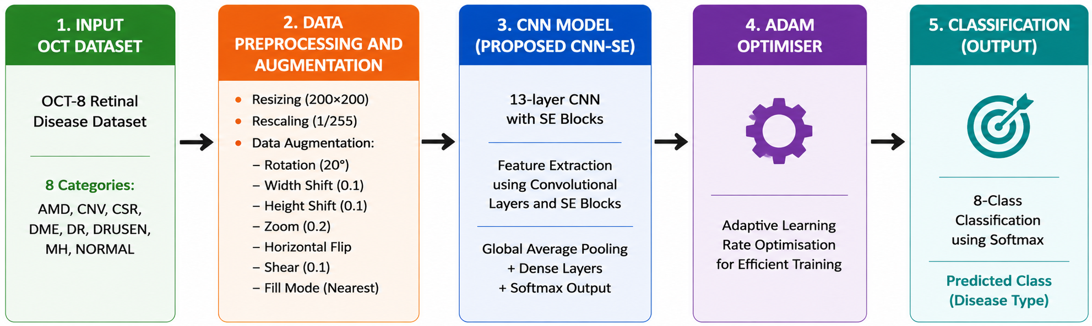
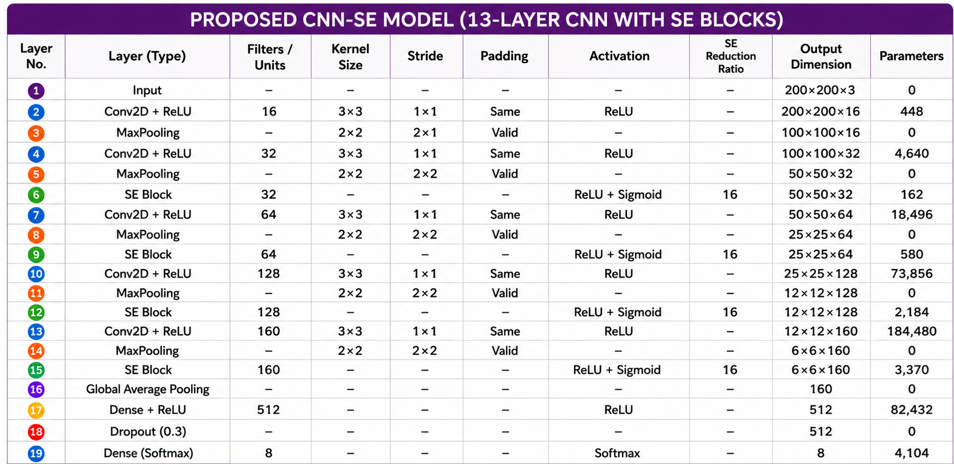
Fig. 1. Proposed CNN Model (OCT-C8: 8 Class, OCT 2017: 4 Class)

- Data Preparation
The OCT-C8 dataset [26] contains 8 classes: Drusen, MH, AMD, CNV, CSR, DME, DR, and Normal. There are 2,800 validation (350 per class), 2800 test images (350 per class) and 18,400 training images (2,300 per class). Feature extraction is more difficult because each image has a resolution of 96 dpi with a 24-bit depth and contains noise and different intensity patterns.
The OCT2017 dataset [17] comprises 83,484 training images, 968 test images (242 per class), and 32 validation images, divided into four classes: CNV, DME, Drusen, and Normal. While example samples, the training images vary in size and contain noise. The publicly available OCT dataset was used as provided by its original authors, with images collected from different patients. Before model training, the images were resized to 200 × 200 pixels using bilinear interpolation, converted to RGB format, and normalized to the range [0,1]. No additional quality screening or duplicate removal was performed, as the dataset was used in its original curated form.

- Data Augmentation
By transforming the source images, image augmentation creates a variety of training examples that aid CNN in learning minor differences across comparable classes [29]. This lessens overfitting, increases generalization, and improves feature representation. Table 2 lists the augmentation settings utilized in the suggested strategy, which creates augmented images during training without storing them permanently.
To improve the model’s ability to generalize while preserving the anatomical characteristics of retinal OCT images, augmentation was applied exclusively to the training set. The training images were subjected to controlled transformations, including horizontal flipping, small-angle rotation, limited horizontal and vertical translation, moderate zooming, and mild shearing, to introduce realistic variations in image appearance and spatial alignment. These transformations increase the diversity of the training distribution and encourage the network to learn stable, discriminative retinal features rather than relying on specific image orientations or local patterns. Vertical flipping and excessive geometric transformations were deliberately avoided because they may alter the natural arrangement of retinal layers and produce anatomically unrealistic pathological patterns. The augmented samples were generated online during training, so the original images were not permanently duplicated and no augmentation was applied to the validation or test sets. Representative transformed images were also visually inspected to verify that retinal-layer continuity, tissue boundaries, and disease-related morphological structures remained identifiable after augmentation.
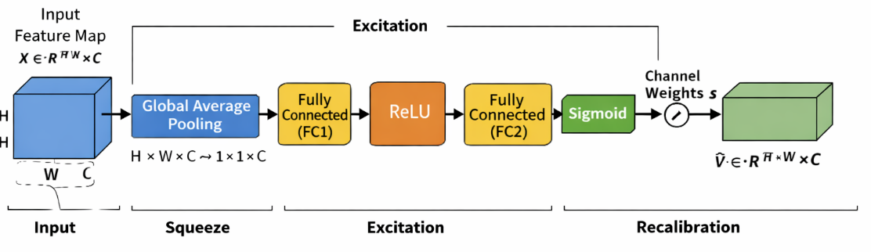
Fig. 2. Architecture of SE block

Table 2. Configuration Details of Image Transformation Techniques
Parameter Name | Parameter Value
Pixel value normalization | 1./255
Rotation angle | 20
Horizontal shift | 0.1
Height shift | 0.1
Zoom factor | 0.2
Horizontal flipping | True
Shear intensity | 0.1
Fill mode | Nearest

- Squeeze-and-Excitation Blocks
The Squeeze-and-Excitation (SE) block[26] by finding the most informative feature channels and simulating channel-wise dependencies, it enhances CNN feature learning. It produces more selective representations of features by enhancing significant traits while suppressing less important ones. The overall architecture for SE block is depicted in Fig. 2.
The operation of the SE block is divided into three key stages: squeeze, excitation, and recalibration. In the squeeze stage, global average pooling is applied to the input feature map $X ∈R^{H* W* C}$ to produce a channel-wise descriptor. In this stage, each channel's spatial dimensions H×W are reduced into one representative value, effectively capturing the global distribution of feature responses. Mathematically, the output of the squeeze operation for the Cth channel is computed as Eq. (1)[30] where Z_{c}​ represents the aggregated statistic of the Cth channel. This descriptor encodes the global contextual information and reflects the overall importance of each channel.

$$Z_{c}=\frac{1}{H*W}\sum_{i=1}^{H}{\sum_{j=1}^{W}{X_{c}\left(i,j\right)}}$$ | (1)

After the squeeze stage, the excitation module learns the importance of each channel using two dense layers with a bottleneck structure. ReLU [31] and sigmoid activations generate normalized channel-wise weights that emphasize informative features while reducing computational cost. This process can be expressed as Eq. (2)[30]

$$S= σ(W_{2}*δ\left(W_{1}*z\right))$$ | (2)

where “z” is the squeezed vector, W₁​ and W₂​ are the learnable parameters of the fully connected layers, δ denotes the ReLU [31] activation, and σ represents the sigmoid function.
In the final feature refinement step, the learned channel parameters are applied to the actual feature map. Each feature channel is scaled based on its assigned importance value, enabling the network to highlight the most meaningful features while minimizing the influence of less important ones. This is given by Eq. (3).

$$\tilde{X}=s_{c}*X_{c}$$ | (3)
where S_{c}​ is the learned weight for the Cth channel. This feature refinement process improves the network's ability to learn meaningful channel-wise information by giving major emphasis to the most pertinent attributes while simultaneously diminishing the impact of less beneficial ones. As a result, the model achieves better classification performance with only a small increase in computational cost.
The global average pooling of SE block can be depicted by Eq. (4)[30]

$G_{c}= \frac{1}{H x W}\sum_{i=1}^{H}{\sum_{j=1}^{W}{X_{c}(i,j)}}$ (4)

- Adam Optimizer
The Adam optimizer is a widely used method for training deep learning models due to its ability to perform well in a variety of scenarios. It integrates the concepts of adaptive learning and momentum, allowing the model to adjust how much each parameter is updated during training. Instead of using the same learning rate for all parameters, Adam adapts it based on the behavior of the gradients, which helps the model learn more efficiently and with better stability. Eq. (5)[32] computes the first moment vector using the first hyperparameter (typically 0.9) to maintain an exponentially decaying average of past gradients that tracks directional momentum.
$m_{t}= β_{1}m_{t-1}+(1-β_{1})g_{t}$ (5)

Eq. (6)[32] calculates the uncentered second moment vector using the second hyperparameter (typically 0.999) to track gradient variance by maintaining an exponentially decaying average of squared gradients.
$v_{t}= β_{2}v_{t-1}+(1-β_{2})g_{t}^{2}$ (6)

Eq. (7)[32] yields the bias-corrected first moment estimate by dynamically adjusting the time step, which compensates for the moving average's initial bias toward zero.
${\hat{m}}_{t}= \frac{m_{t}}{1-β_{1}^{t}}$ (7)
Eq. (8) [32]derives the bias-corrected second moment estimate by adjusting for the time step, correcting the initial zero-bias in variance tracking during early iterations.
${\hat{v}}_{t}=\frac{v_{t}}{1-β_{2}^{t}}$ (8)
Eq. (9)[32] updates the model parameters by adjusting the learning rate with the ratio of these bias-corrected moments, providing adaptive step sizes stabilized by a small constant.

$θ= θ- α* \frac{m}{\left(\sqrt{v}\right)+\left(∈\right)}$ (9)
where m captures the average of past gradients and v represents the average of their squared values. These estimates are continuously updated during training, helping the optimizer adapt to the shape of the loss function. Because of this adaptive behaviour, Adam tends to converge faster and requires less manual tuning compared to traditional optimization methods. It performs particularly well in problems involving large datasets, high-dimensional pameters, or noisy gradients

- CNN Architecture
The proposed CNN processes 200×200×3 OCT images through successive convolution and max-pooling layers to learn hierarchical image features. SE blocks are incorporated after each stage to emphasize important feature channels while suppressing less relevant ones. The gradual increase in filters enables effective feature extraction, leading to improved retinal OCT image classification. The extracted feature maps are condensed using global average pooling and passed to a 512-neuron dense layer with 0.3 dropout to improve generalization. A softmax layer then produces the final class predictions for the OCT-C8 and OCT2017 datasets.
A 2x2 max-pooling procedure follows each convolutional layer to preserve the most informative features while reducing the size of the feature map by keeping just the strongest activations. As seen in Fig. 3 and Eq. (10)[33][34], this increases the computing efficiency and aids in the model’s learning of more robust features.
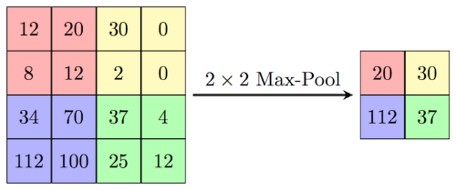
Fig. 3. Illustration of 2x2 max pooling

$$MaxPool(x)=max⁡(x_{ij}) _{1≤i≤k,1≤j≤k}$$ | (10)
The ReLU [31] activation function is used throughout the CNN to introduce non-linearity by retaining positive values and suppressing negative ones. Its computational efficiency and ability to mitigate the vanishing gradient problem enable faster and more stable network convergence. The mathematical equation is depicted by Eq. (11) [31]
F(x) = max(x, 0) | (11)
The 6×6×160 feature maps are compressed by global average pooling into a 1×1×160 feature vector following the final convolution and max-pooling stage, and then they are sent to a 512-neuron dense layer for discriminative feature learning. To lessen overfitting and enhance model generalisation, a dropout rate of 0.3 is used during training. Eight neurons are used in the last output layer for the OCT-C8 [23] dataset and four neurons for the OCT2017 [15] dataset, with each neuron representing a distinct class to generate the final classification results. The last layer uses the softmax activation function to calculate the likelihood of each output class. Using these probabilities, the framework assigns the input picture to the class with the greatest confidence score. The suggested model minimizes the discrepancy between the true and predicted class labels during training by using categorical cross-entropy loss for multi-class classification.
The equation, Eq. (12)[8][10] , represents a 2D convolutional layer where a filter matrix with a bias value slide across an input image to calculate a weighted sum at each overlapping region. This mathematical operation extracts localized spatial features from the input data to produce a specific coordinate pixel value within the output feature map, as detailed in Eq. (12)[8][10].

$Y\left(i,j\right)= \sum_{m=0}^{K-1}{\sum_{n=0}^{K-1}{X\left(i+m,j+n\right)*W\left(m,n\right)+b}}$ (12)

The spatial dimensions of the output feature map after convolution are calculated Eq. (13)[8], determines the final spatial output size of a feature map by adding twice the padding (P) to the input dimension (N) and subtracting the kernel size (K). This result is then divided by the stride rate (S), rounded down to the nearest integer using the floor function, and increased by one to account for the final filter placement, as outlined in Eq. (13)[8].

$O= \left\lfloor \frac{N-K+2P}{S}\right.\left.\frac{ }{ }\right\rfloor +1$ (13)
The mathematical formulation of the softmax function is presented in Eq. (14). The function transforms the output values of the network into normalized probability scores ranging from 0 to 1, with the total probability across all classes equal to one. In Eq. (14), Z represents the input vector received by the output layer, and j refers to an individual output neuron, where j = 1, 2, ..., K.
$${σ(z)}_{j}= \frac{e^{{(z)}_{j}}}{\sum_{k=1}^{K}{e^{{(z)}_{k}}}}$$ | (14)
The dense layer transforms the extracted features into a higher-level representation as shown in Eq. (15)[9] , where (W) denotes the weight matrix, (x) represents the input feature vector, (b) is the bias, and (f(.)) denotes the ReLU activation function.This transformation enables the network to learn complex feature representations for accurate classification
$h=f\left(Wx+b\right)$ (15)
As discussed, earlier dropout cand be denoted by Eq. (16)[35] which reduces the overfitting to make a model generalized one.
$h_{drop}=r ⨀ h$ , $r ∼Bernoulli(p)$ (16)

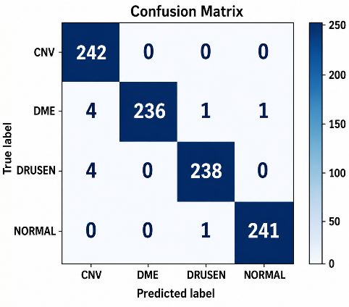 | 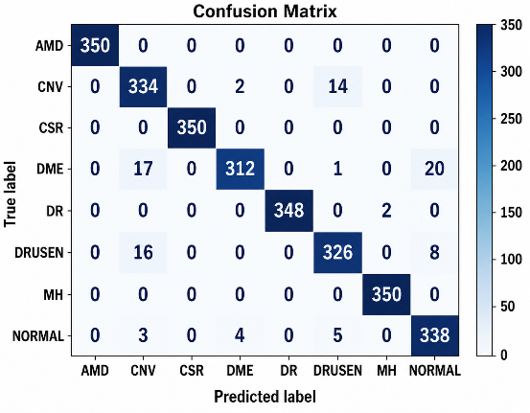
Fig. 4. Confusion matrix for OCT2017(left) and OCT-C8(right) test datasets

Evaluation Setup and Experimental Findings
The proposed CNN–SE model was implemented in Python 3.12.13 using TensorFlow 2.21.0, Keras, scikit-learn, and Matplotlib on an AMD Ryzen 7 5700G (3.80 GHz) CPU with 16 GB RAM. The model used 200 × 200 × 3 input images, a batch size of 32, Adam optimization with a learning rate of 0.001, categorical cross-entropy loss, an SE reduction ratio of 16, and a dropout rate of 0.30. Training was performed for a maximum of 100 epochs with early stopping (patience = 20), retaining the best-performing weights; convergence occurred at epoch 31 for OCT2017 [17] and epoch 63 for OCT-C8 [26]. The same hyperparameter configuration was applied to both datasets without test-set-specific tuning. OCT-C8 [26] contained 18,400 training and 2,800 validation/testing images, whereas OCT2017 [17] contained 83,484 training, 32 validation, and 968 testing images. The lightweight CNN–SE model required approximately 13 h/109 ms for training/testing on OCT2017 and 6 h/144 ms on OCT-C8. Performance was comprehensively evaluated using confusion matrices, ROC curves, training–validation curves, and class-wise evaluation metrics.
The confusion matrices for the OCT2017 and OCT-C8 test datasets are presented in Fig. 4. Most predictions are concentrated along the diagonal, indicating effective discrimination across the evaluated retinal categories, although a small number of errors were observed, particularly for DME and Drusen in OCT2017. The performance difference between the datasets can be partly attributed to the larger number of classes and higher degree of inter-class morphological similarity in OCT-C8. In this dataset, the remaining errors were mainly observed among CNV, DME, Drusen, and Normal, where overlapping OCT characteristics such as retinal thickening, intraretinal or subretinal fluid, and variations in retinal reflectivity can make class boundaries less distinct. Subtle or localized abnormalities may also cause some diseased scans to resemble normal retinal structures. In contrast, AMD, CSR, DR, and MH showed comparatively fewer misclassifications, suggesting that their structural patterns were more readily distinguished by the learned feature representations. Overall, the observed errors were primarily associated with visually similar or less pronounced retinal abnormalities, while the strong diagonal pattern across both confusion matrices indicates that these cases had limited impact on the overall classification performance.
The training and validation loss curves for the OCT2017 and OCT-C8 datasets are shown in Fig. 5(a) and Fig. 5(b). Smooth decreases in both curves with a small training–validation gap indicate stable convergence without substantial overfitting. Owing to its larger training set, fewer classes, and lower inter-class complexity, OCT2017 converges faster than OCT-C8. The corresponding training and validation accuracy curves are presented in Fig. 6(a) and Fig. 6(b), showing a consistent increase with closely aligned curves, which indicates stable learning and good generalization. Although OCT-C8 converges more slowly because of its higher class complexity and inter-class similarity, the model maintains strong classification performance on both datasets.
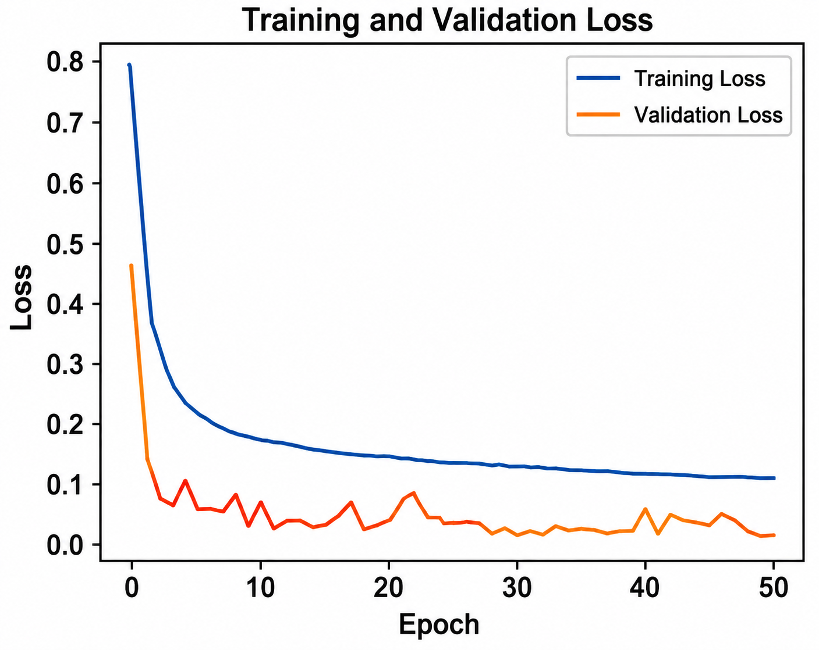
(a)
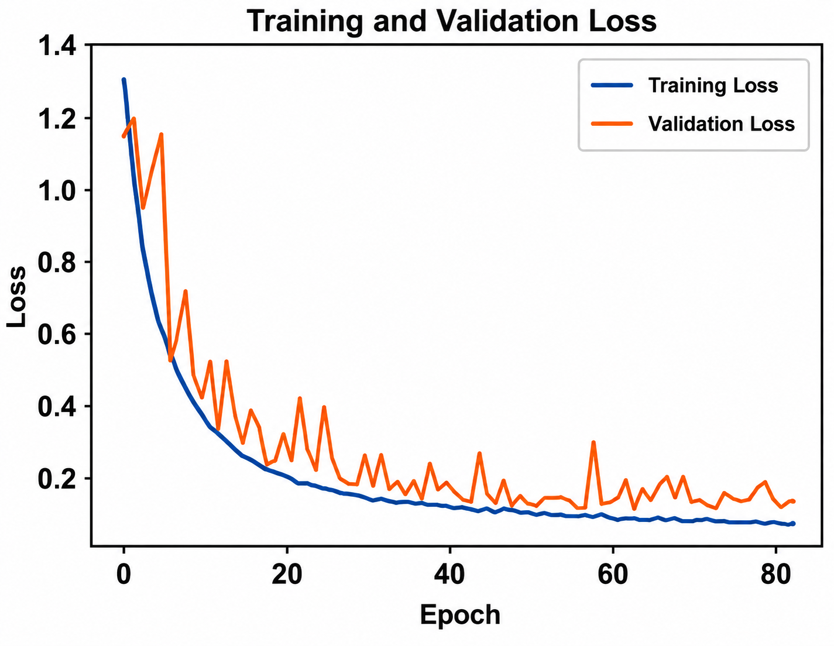
(b)
Fig. 5 (a) Training and validation loss for OCT2017 dataset (b) Training and validation loss for OCT-C8 dataset
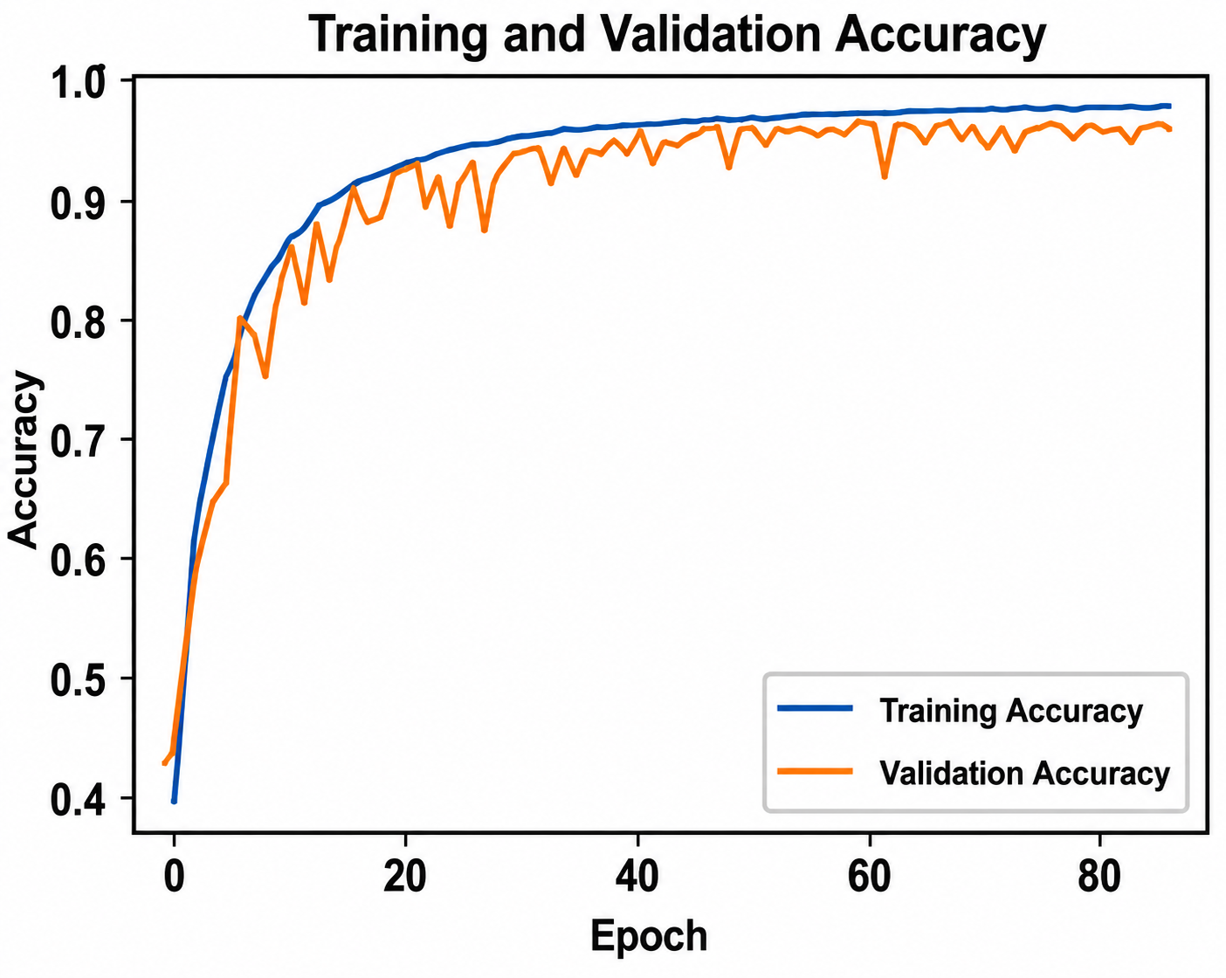
(b)
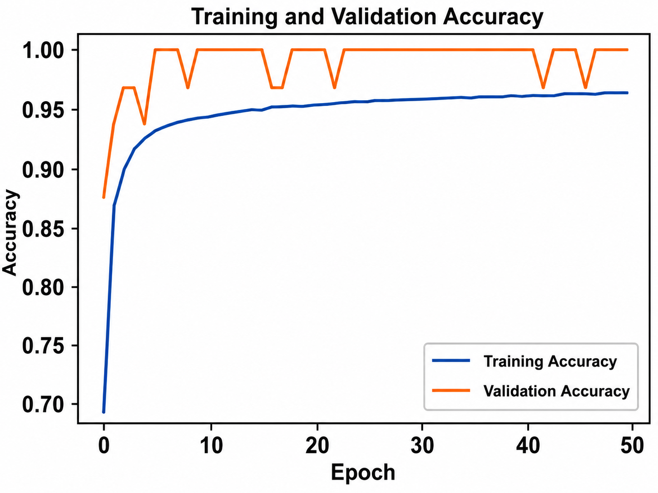
(a)
Fig. 6 (a). Training and validation accuracy for OCT2017 dataset (b). Training and validation accuracy for OCT-C8 dataset

Table 3 summarizes the class-wise classification performance of the proposed CNN-SE model on the OCT2017 and OCT-C8 datasets. On OCT2017, the model achieved an overall accuracy of 99%, with precision, recall, and F1-score values close to 1.00 across CNV, DME, Drusen, and Normal. For OCT-C8, the model obtained an overall accuracy of 97%, with the highest class-wise performance observed for CNV, DME, Drusen, and Normal, while AMD, CSR, DR, and MH also showed strong classification results. The macro- and weighted-average metrics were consistently 0.99 for OCT2017 and 0.97 for OCT-C8, indicating balanced performance across the evaluated classes despite the higher class diversity and morphological similarity in OCT-C8.

Table 3 Class-wise Classification Results of CNN-SE Model for OCT2017 and OCT-C8 datasets
 | OCT 2017 |  |  |  | OCT-C8
 | Precision | Recall | F1-score | Support | Precision | Recall | F1-score | Support
Class
AMD | Class Not Available |  |  |  | 1.00 | 1.00 | 1.00 | 350
CNV | 0.97 | 1.00 | 0.98 | 242 | 0.90 | 0.95 | 0.93 | 350
CSR | Class Not Available |  |  |  | 1.00 | 1.00 | 1.00 | 350
DME | 1.00 | 0.98 | 0.99 | 242 | 0.98 | 0.89 | 0.93 | 350
DR | Class Not Available |  |  |  | 1.00 | 0.99 | 1.00 | 350
Drusen | 0.99 | 0.98 | 0.99 | 242 | 0.94 | 0.93 | 0.94 | 350
MH | Class Not Available |  |  |  | 0.99 | 1.00 | 1.00 | 350
Normal | 1.00 | 1.00 | 1.00 | 242 | 0.92 | 0.97 | 0.94 | 350
Accuracy |  |  | 0.99 | 968 |  |  | 0.97 | 2800
Macro Avg | 0.99 | 0.99 | 0.99 | 968 | 0.97 | 0.97 | 0.97 | 2800
Weighted Avg | 0.99 | 0.99 | 0.99 | 968 | 0.97 | 0.97 | 0.97 | 2800

$Accuracy= \frac{TP+TN}{TP+TN+FP+FN}$ (17)
$Precision= \frac{TP}{TP+FP}$ (18)
$Recall= \frac{TP}{TP+FN}$ (19)
$F1-Score=2* \frac{Precision*Recall}{Precision+Recall}$ (20)

The model was evaluated using Eqs. (17), (18), (19) and (20)[36][37]

- Cross-Dataset Validation
To further examine domain robustness, the CNN-SE model was trained exclusively on OCT-C8 and evaluated directly on the OCT2017 dataset without retraining or fine-tuning, using the four shared diagnostic classes, namely CNV, DME, Drusen, and Normal. Across five repeated experiments with random seeds 11, 22, 33, 44, and 55, the model achieved an overall accuracy of 98.74 ± 0.11%, with weighted precision, recall, and F1-score of 98.75 ± 0.12%, 98.74 ± 0.11%, and 98.74 ± 0.11%, respectively. The corresponding macro-ROC-AUC of 0.9995 ± 0.0002 indicates consistent discrimination across the
Table 4. Cross-Dataset Testing Performance of the Proposed CNN-SE Model Across Five Random Seeds
Metric | Mean | SD | Mean ± SD
Accuracy | 0.987397 | 0.001132 | 98.74 ± 0.11%
Weighted Precision | 0.987460 | 0.001153 | 98.75 ± 0.12%
Weighted Recall | 0.987397 | 0.001132 | 98.74 ± 0.11%
Weighted F1-score | 0.987397 | 0.001141 | 98.74 ± 0.11%
Macro F1-score | 0.987397 | 0.001141 | 98.74 ± 0.11%
Macro ROC-AUC | 0.999545 | 0.000236 | 0.9995 ± 0.0002
Compatible Prediction Rate | 1.000000 | 0.000000 | 100.00 ± 0.00%

evaluated classes, while the 100.00 ± 0.00% compatible prediction rate confirms that all evaluated samples were mapped to the intended diagnostic categories across the repeated experiments. These findings provide evidence of stable cross-dataset robustness and generalization, summarized in Table 4

- Computational Efficiency and Inference Performance
The computational characteristics of the proposed SE-CNN were further examined against MobileNetV2, EfficientNetB0, and NASNetMobile using a consistent evaluation procedure as described in Table 5. With only 0.3748 M trainable parameters, 0.3670 G FLOPs, and 183.52 M MACs, the proposed network occupied just 1.54 MB and required an average of 9.40 ms to process an image. It also recorded the highest inference throughput among the evaluated models, reaching 106.4 images/s. These measurements show that the proposed architecture achieves its feature-recalibration capability without introducing the computational burden typically associated with larger networks. The resulting combination of a small model footprint and rapid inference indicates a favorable efficiency profile for retinal OCT classification, particularly in settings where computational resources may be limited.
In terms of diagnostic performance, the proposed CNN–SE model achieved 96.71% accuracy on the OCT-C8 test set, with a macro-AUROC of 0.9985, indicating strong discriminative capability. In the independent cross-dataset evaluation, where the model was trained on OCT-C8 and tested on OCT2017 across five random seeds as stated earlier, it achieved 98.74 ± 0.11% accuracy and 0.9995 ± 0.0002 macro-AUROC. The corresponding MCC (0.9832 ± 0.0015) and Cohen’s κ (0.9832 ± 0.0015) further demonstrate strong agreement and stable classification performance on the external dataset as presented in Table 6.

Table 5 Computational Efficiency Comparison of CNN Models
Model | Parameters (Millions) | FLOPs (G) | MACs (M) | Model Size (MB) | Peak Memory (MB) | Latency (ms/image) | Throughput (images/s)
Proposed SE-CNN | 0.3748 | 0.3670 | 183.52 | 1.54 | 0.00 | 9.40 | 106.40
MobileNetV2 | 2.2682 | 0.5342 | 267.09 | 9.21 | 0.0039 | 42.13 | 23.74
EfficientNetB0 | 4.0598 | 0.7083 | 354.16 | 16.29 | 0.0312 | 62.01 | 16.13
NASNetMobile | 4.2782 | 0.9983 | 499.15 | 18.95 | 0.0703 | 82.93 | 12.06

Table 6 Within-Dataset and Cross-Dataset Validation Results
Train Dataset → Test Dataset | Test Set (#) | Accuracy (%) | Macro-AUROC | MCC | Cohen’s κ
OCT-C8 → OCT-C8 | 2,800 | 96.71 | 0.9985 | 0.9626 | 0.9624
OCT-C8 → OCT2017 | 968 | 98.74 ± 0.11 | 0.9995 ± 0.0002 | 0.9832 ± 0.0015 | 0.9832 ± 0.0015

- Ablation Study
To systematically assess the individual contributions of the SE blocks, data augmentation, and optimizer selection under the same training and testing settings, ablation research was carried out using the OCT2017 and OCT-C8 datasets.
At the beginning, a basic CNN model was trained without including SE blocks and without applying data augmentation. We call it Model A for the denotation which is shown in Fig. 1 in that SE blocks are not included. This architecture showed lower classification performance, especially for classes like CNV, DME, and Drusen where the features are quite similar. Since no augmentation was used, the training data lacked variation, which made it harder for the model to generalize well on unseen test dataset images. In the second model implementation: Model B, data augmentation was added while keeping the model architecture the same as Model A. With more varied training samples, the model was able to learn better patterns, which improved overall accuracy and reduced overfitting. There was also a clear improvement in recall, especially for minority classes and those with similar visual features.
While Model D indicated that substituting SGD for Adam led to slower convergence and somewhat reduced accuracy, Model C showed that adding SE blocks enhanced feature representation and classification performance, especially for structurally related retinal disorders. By strengthening feature learning, boosting generalization, and guaranteeing stable optimization, the suggested Model E—which combined SE blocks, data augmentation, and the Adam optimizer—achieved the best overall performance. The ablation findings verify that each element adds to the model’s efficacy, and when combined, they produce the most robust and well-balanced retinal OCT image. The results of the ablation study are briefly presented in Table 7.
To examine the contribution of the main components, the ablation results were analyzed through controlled pairwise comparisons using the configurations reported in the study presented by Table 8. Removing the SE blocks reduced OCT2017 accuracy from 97.9% to 96.2%, while adding augmentation improved the baseline from 96.2% to 97.8%; similarly, replacing SGD with Adam increased OCT2017 accuracy from 95.3% to 99.0% and OCT-C8 accuracy from 94.1% to 97.0%. These comparisons indicate that SE blocks, data augmentation, and optimizer selection contribute to the overall performance of the proposed model. Among the tested factors, the optimizer changes from SGD to Adam produced the largest observed improvement. Alternative SE reduction ratios, pooling strategies, and dropout rates were not included in the reported experiments and therefore no unsupported conclusions are drawn for these components.

Table 7 Ablation study of different model implementations
Model | SE Blocks | Data Augmentation | Optimizer | Accuracy (OCT2017) | Accuracy (OCT-C8)
Model A | No | No | Adam | 96.2% | 92.8%
Model B | No | Yes | Adam | 97.8% | 94.6%
Model C | Yes | No | Adam | 97.9% | 94.87%
Model D | Yes | Yes | SGD | 95.3% | 94.1%
Model E (Proposed Model) | Yes | Yes | Adam | 99.0% | 97.0%

Table 8 Component wise ablation study analysis (pp = percentage point)
Comparison | Component isolated | OCT2017 Accuracy Change | OCT-C8 Accuracy Change
Model A → Model B | Data augmentation | +1.60 pp | +1.80 pp
Model A → Model C | SE blocks | +1.70 pp | +2.07 pp
Model D → Model E | Optimizer (SGD → Adam) | +3.70 pp | +2.90 pp
Model C → Model E | Data augmentation | +1.10 pp | +2.13 pp

- Comparison with existing approaches
Table 9 presents a comprehensive comparison of the proposed model against existing state-of-the-art techniques evaluated on the OCT2017 and OCT-C8 datasets. This comparative analysis was conducted to contextualize the performance of the proposed CNN-SE architecture relative to previously published approaches, taking into account differences in network depth, parameter count, and optimization strategies employed across the literature. Such benchmarking is essential not only to validate the effectiveness of the proposed method but also to identify the specific architectural choices that contribute to performance gains over conventional CNN-based classifiers.
Existing CNN-based approaches applied to the OCT2017 dataset have reported classification accuracies ranging from 88.4% to 98.75%, with differences arising from network architecture, preprocessing, data augmentation, dataset partitioning, and evaluation protocols. Therefore, the accuracy values reported in the literature are considered reference values rather than strictly equivalent benchmark results. Within this context, the proposed CNN-SE model achieves 99.00% accuracy on OCT2017, demonstrating a strong performance while maintaining a comparatively lightweight architecture. Furthermore, the proposed model achieves 97.00% accuracy on the OCT-C8 dataset, an eight-class classification problem with higherraw inter-class similarity. The strong performance across both datasets provides additional evidence of the model’s generalization capability beyond a single dataset distribution. To further assess generalization across dataset distributions, cross-dataset validation was performed by training exclusively on the OCT-C8 training set and evaluating on the independent OCT2017 test set without additional training or fine-tuning. Across repeated runs, this evaluation achieved 98.74 ± 0.11% accuracy, 98.75 ± 0.12% weighted precision, 98.74 ± 0.11% weighted recall and F1-score, and a macro-ROC-AUC of 0.9995 ± 0.0002. These results provide additional evidence of consistent generalization beyond a single dataset distribution.

Table 9. Comparison with existing approaches
Publication Year | References | Approach | Acc (OCT2017 Dataset) | Acc (OCT-C8 Dataset)
2019 | L.Huang et al. [16] | Layer-guided convolutional neural network | 88.4
2020 | Le et al.[38] | Transfer learning | 87.20
2020 | Saraiva et al. [39] | Deep CNN architecture | 93.3
2021 | J Kim et al. [18] | Two binary CNN variants (Model 1 / Model 2 with high computational complexity) | 98.1/98.7
2023 | Hassan E et al [20] | Enhanced Optical Coherence Tomography (EOCT)-based framework | 97.47
2023 | Diao et al. [19] | CNN-based classification framework | 96.93
2023 | Michael Opoku et al. [40] | Capsule network integrated with contrast-limited adaptive histogram equalization | 97.7
2024 | Stanojevi´c, M et al. [24] | Deep convolutional neural network model | 95.55
2024 | Yang J et al. [23] | CNN, EfficientNet-V2, and ResNet-based ensemble architecture | 97.89
2025 | Dave and Domadiya et al. [28] | CNN with data augmentation, exponential learning rate decay, and hybrid max–average pooling | 98.75
2026 | Proposed Model | CNN enhanced with SE blocks, Adam optimization, and global average pooling | 99.00 | 97.00

- Explainable AI
Grad-CAM analysis was performed to examine the spatial features contributing to the predictions of the proposed CNN-SE model across the eight OCT-C8 classes, as illustrated in Fig. 7. The activation maps predominantly highlighted localized retinal regions associated with class-discriminative structural patterns, with stronger responses observed around abnormal retinal morphology in AMD, CNV, CSR, DME, DR, Drusen, and MH, whereas Normal samples generally exhibited more localized activation within the retinal layers. The concentration of activations around relevant retinal structures suggests that the learned convolutional representations capture spatially meaningful features for disease discrimination, particularly in cases involving subtle or overlapping morphological characteristics. Grad-CAM visualizations of representative misclassified samples further illustrate regions associated with the model’s incorrect predictions and provide additional insight into challenging class boundaries. Since Grad-CAM reflects the contribution of image regions to a model prediction rather than causal evidence of a specific pathological feature, these visualizations are interpreted as an explanatory analysis of the learned feature representations rather than a clinical localization method.

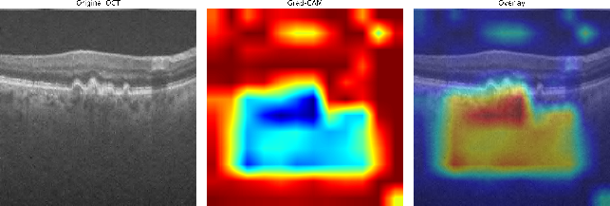  AMD | 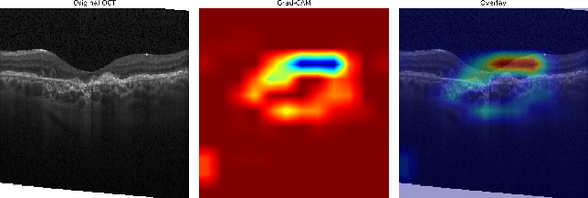  CNV
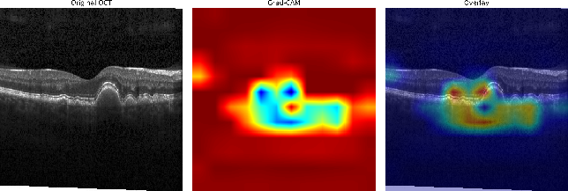  DRUSEN | 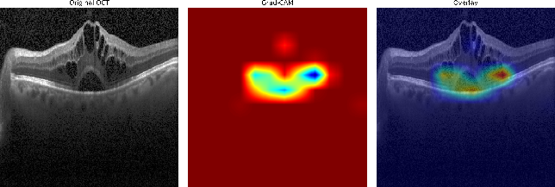  DME
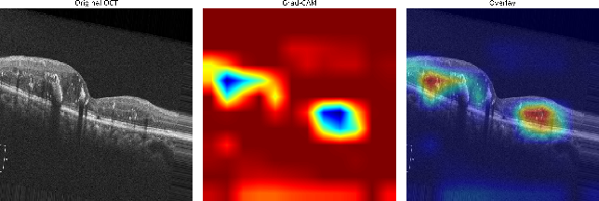  DR | 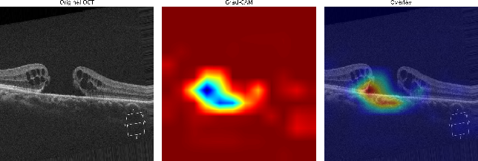  MH
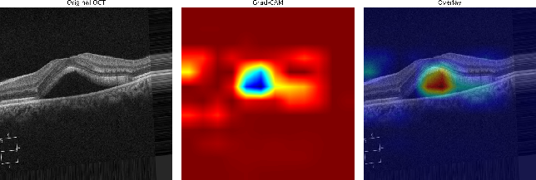  CSR | 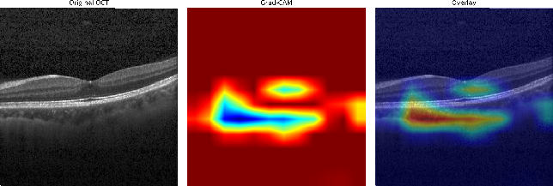  Normal
Fig. 7. Grad-CAM visualizations of representative OCT-C8 dataset

Conclusion and Future Work
This study presented a lightweight CNN-SE framework for retinal OCT image classification by integrating SE blocks, data augmentation, and the Adam optimizer. The proposed model achieved 99.00% and 97.00% accuracy on the OCT2017 and OCT-C8 datasets, respectively, while maintaining a compact computational profile. The five-seed cross-dataset evaluation further achieved 98.74 ± 0.11% accuracy and 0.9995 ± 0.0002 macro-ROC-AUC when the model trained on OCT-C8 was evaluated directly on OCT2017, providing evidence of robustness across the two dataset distributions. Grad-CAM analysis also provided visual insight into the image regions contributing to the model predictions.
Despite these encouraging findings, several limitations should be considered. The study relies on publicly available curated datasets, and no external hospital-based prospective validation was performed. Differences in OCT scanners, acquisition protocols, patient populations, and clinical settings may therefore affect model performance under real-world conditions. In addition, patient-level prospective testing was not available in the present study. Future work will focus on evaluating the proposed model using multi-center, hospital-based OCT datasets with diverse acquisition conditions, patient-level evaluation, and prospective clinical validation to establish its robustness and clinical applicability.
Acknowledgment
NA
Funding
NA

Data Availability
No datasets were generated during the current study. The datasets used in the research are publicly available and we have cited it properly in the paper [17] and [26].
Author Contribution
Parth R. Dave:- Conceptualization, methodology, data curation, model implementation, formal analysis, manuscript drafting, review and editing, and project coordination.
Nikunj H. Domadiya:- Conceptualization, methodology, supervision, performance evaluation, formal and statistical analysis, visualization, manuscript drafting, review and editing.
Jaiwal Patel:- Mathematical foundation, abstract analysis, manuscript editing and drafting, project execution, and ablation study
Declarations
The authors declare no conflict of interest.

Consent for Publication Participants.
Consent for publication was given by all participants

Competing Interests
The authors declare no competing interests.
References

[1] T. Ojala, M. Pietikainen, and T. Maenpaa, “Multiresolution gray-scale and rotation invariant texture classification with local binary patterns,” IEEE Trans. Pattern Anal. Mach. Intell., vol. 24, no. 7, pp. 971–987, Jul. 2002, doi: 10.1109/TPAMI.2002.1017623.
[2] N. Dalal and B. Triggs, “Histograms of Oriented Gradients for Human Detection,” in 2005 IEEE Computer Society Conference on Computer Vision and Pattern Recognition (CVPR’05), IEEE, pp. 886–893. doi: 10.1109/CVPR.2005.177.
[3] R. M. Haralick, K. Shanmugam, and I. Dinstein, “Textural Features for Image Classification,” IEEE Trans. Syst. Man Cybern., vol. SMC-3, no. 6, pp. 610–621, Nov. 1973, doi: 10.1109/TSMC.1973.4309314.
[4] G. Li, G. Wang, Q. Wang, F. Fei, S. Lü, and D. Guo, “ANN: a heuristic search algorithm based on artificial neural networks,” in Proceedings of the 1st International Conference on Intelligent Information Processing, in ICIIP ’16. New York, NY, USA: Association for Computing Machinery, 2016. doi: 10.1145/3028842.3028893.
[5] M. A. Hearst, S. T. Dumais, E. Osuna, J. Platt, and B. Scholkopf, “Support vector machines,” IEEE Intelligent Systems and their Applications, vol. 13, no. 4, pp. 18–28, Jul. 1998, doi: 10.1109/5254.708428.
[6] R. Chauhan, K. K. Ghanshala, and R. C. Joshi, “Convolutional Neural Network (CNN) for Image Detection and Recognition,” in 2018 First International Conference on Secure Cyber Computing and Communication (ICSCCC), 2018, pp. 278–282. doi: 10.1109/ICSCCC.2018.8703316.
[7] B. Zoph, V. Vasudevan, J. Shlens, and Q. V. Le, “Learning Transferable Architectures for Scalable Image Recognition,” in 2018 IEEE/CVF Conference on Computer Vision and Pattern Recognition, IEEE, Jun. 2018, pp. 8697–8710. doi: 10.1109/CVPR.2018.00907.
[8] A. Krizhevsky, I. Sutskever, and G. E. Hinton, “ImageNet classification with deep convolutional neural networks,” Commun. ACM, vol. 60, no. 6, pp. 84–90, May 2017, doi: 10.1145/3065386.
[9] K. Simonyan and A. Zisserman, “Very Deep Convolutional Networks for Large-Scale Image Recognition,” Apr. 2015.
[10] K. He, X. Zhang, S. Ren, and J. Sun, “Deep Residual Learning for Image Recognition,” in 2016 IEEE Conference on Computer Vision and Pattern Recognition (CVPR), IEEE, Jun. 2016, pp. 770–778. doi: 10.1109/CVPR.2016.90.
[11] C. Szegedy et al., “Going deeper with convolutions,” in 2015 IEEE Conference on Computer Vision and Pattern Recognition (CVPR), IEEE, Jun. 2015, pp. 1–9. doi: 10.1109/CVPR.2015.7298594.
[12] P. P. Srinivasan et al., “Fully automated detection of diabetic macular edema and dry age-related macular degeneration from optical coherence tomography images,” Biomed. Opt. Express, vol. 5, no. 10, p. 3568, Oct. 2014, doi: 10.1364/BOE.5.003568.
[13] Y.-Y. Liu et al., “Computerized Macular Pathology Diagnosis in Spectral Domain Optical Coherence Tomography Scans Based on Multiscale Texture and Shape Features,” Investigative Opthalmology & Visual Science, vol. 52, no. 11, p. 8316, Oct. 2011, doi: 10.1167/iovs.10-7012.
[14] A. Maćkiewicz and W. Ratajczak, “Principal components analysis (PCA),” Comput. Geosci., vol. 19, no. 3, pp. 303–342, 1993, doi: https://doi.org/10.1016/0098-3004(93)90090-R.
[15] K. Alsaih et al., “Classification of SD-OCT volumes with multi pyramids, LBP and HOG descriptors: Application to DME detections,” in 2016 38th Annual International Conference of the IEEE Engineering in Medicine and Biology Society (EMBC), IEEE, Aug. 2016, pp. 1344–1347. doi: 10.1109/EMBC.2016.7590956.
[16] L. Huang, X. He, L. Fang, H. Rabbani, and X. Chen, “Automatic Classification of Retinal Optical Coherence Tomography Images With Layer Guided Convolutional Neural Network,” IEEE Signal Process. Lett., vol. 26, no. 7, pp. 1026–1030, Jul. 2019, doi: 10.1109/LSP.2019.2917779.
[17] D. S. Kermany et al., “Identifying Medical Diagnoses and Treatable Diseases by Image-Based Deep Learning,” Cell, vol. 172, no. 5, pp. 1122-1131.e9, Feb. 2018, doi: 10.1016/j.cell.2018.02.010.
[18] J. Kim and L. Tran, “Retinal Disease Classification from OCT Images Using Deep Learning Algorithms,” in 2021 IEEE Conference on Computational Intelligence in Bioinformatics and Computational Biology (CIBCB), IEEE, Oct. 2021, pp. 1–6. doi: 10.1109/CIBCB49929.2021.9562919.
[19] S. Diao et al., “Classification and segmentation of OCT images for age-related macular degeneration based on dual guidance networks,” Biomed. Signal Process. Control, vol. 84, p. 104810, Jul. 2023, doi: 10.1016/j.bspc.2023.104810.
[20] E. Hassan et al., “Enhanced Deep Learning Model for Classification of Retinal Optical Coherence Tomography Images,” Sensors, vol. 23, no. 12, p. 5393, Jun. 2023, doi: 10.3390/s23125393.
[21] C. S. Lee, D. M. Baughman, and A. Y. Lee, “Deep Learning Is Effective for Classifying Normal versus Age-Related Macular Degeneration OCT Images,” Ophthalmol. Retina, vol. 1, no. 4, pp. 322–327, 2017, doi: https://doi.org/10.1016/j.oret.2016.12.009.
[22] D. Paul, A. Tewari, S. Ghosh, and K. C. Santosh, “OCTx: Ensembled Deep Learning Model to Detect Retinal Disorders,” in 2020 IEEE 33rd International Symposium on Computer-Based Medical Systems (CBMS), IEEE, Jul. 2020, pp. 526–531. doi: 10.1109/CBMS49503.2020.00105.
[23] J. Yang, G. Wang, X. Xiao, M. Bao, and G. Tian, “Explainable ensemble learning method for OCT detection with transfer learning,” PLoS One, vol. 19, no. 3, p. e0296175, Mar. 2024, doi: 10.1371/journal.pone.0296175.
[24] M. Stanojević, D. Drašković, and B. Nikolić, “Retinal disease classification based on optical coherence tomography images using convolutional neural networks,” J. Electron. Imaging, vol. 32, no. 03, Nov. 2022, doi: 10.1117/1.JEI.32.3.032004.
[25] M. Selvarajan and M. B. N. M, “Impact of Optimizer Algorithm on NasNetMobile Model for Eight-class Retinal Disease Classification from OCT Images,” Journal of Electronics, Electromedical Engineering, and Medical Informatics, vol. 8, no. 2, pp. 490–503, Mar. 2026, doi: 10.35882/jeeemi.v8i2.1464.
[26] Obuli Sai Naren, “Retinal OCT Image Classification - C8 [Data set],” https://www.kaggle.com/datasets/obulisainaren/retinal-oct-c8/versions/2. Accessed: Jul. 20, 2026. [Online]. Available: https://doi.org/10.34740/KAGGLE/DSV/2736749
[27] F. E. Jannat, S. Gholami, M. N. Alam, and H. Tabkhi, “OCT-SelfNet: a self-supervised framework with multi-source datasets for generalized retinal disease detection,” Front. Big Data, vol. 8, 2025, doi: 10.3389/fdata.2025.1609124.
[28] P. R. Dave and N. H. Domadiya, “Lightweight deep learning approach for retinal OCT image classification: A CNN with hybrid pooling and optimized learning,” International Journal of Informatics and Communication Technology (IJ-ICT), vol. 15, no. 1, p. 414, Mar. 2026, doi: 10.11591/ijict.v15i1.pp414-427.
[29] Z. Yang, R. O. Sinnott, J. Bailey, and Q. Ke, “A survey of automated data augmentation algorithms for deep learning-based image classification tasks,” Knowl. Inf. Syst., vol. 65, no. 7, pp. 2805–2861, 2023, doi: 10.1007/s10115-023-01853-2.
[30] J. Hu, L. Shen, and G. Sun, “Squeeze-and-Excitation Networks,” in 2018 IEEE/CVF Conference on Computer Vision and Pattern Recognition, IEEE, Jun. 2018, pp. 7132–7141. doi: 10.1109/CVPR.2018.00745.
[31] V. Nair and G. E. Hinton, “Rectified Linear Units Improve Restricted Boltzmann Machines.”
[32] D. P. Kingma and J. Ba, “Adam: A Method for Stochastic Optimization,” CoRR, vol. abs/1412.6980, 2014, [Online]. Available: https://api.semanticscholar.org/CorpusID:6628106
[33] C. Szegedy et al., “Going deeper with convolutions,” in 2015 IEEE Conference on Computer Vision and Pattern Recognition (CVPR), 2015, pp. 1–9. doi: 10.1109/CVPR.2015.7298594.
[34] H. Wu and X. Gu, “Max-Pooling Dropout for Regularization of Convolutional Neural Networks,” vol. 9489, 2015, pp. 46–54. doi: 10.1007/978-3-319-26532-2_6.
[35] N. Srivastava, G. Hinton, A. Krizhevsky, I. Sutskever, and R. Salakhutdinov, “Dropout: a simple way to prevent neural networks from overfitting,” J. Mach. Learn. Res., vol. 15, no. 1, pp. 1929–1958, Jan. 2014.
[36] M. Sokolova and G. Lapalme, “A systematic analysis of performance measures for classification tasks,” Inf. Process. Manag., vol. 45, no. 4, pp. 427–437, 2009, doi: https://doi.org/10.1016/j.ipm.2009.03.002.
[37] T. Fawcett, “An introduction to ROC analysis,” Pattern Recognit. Lett., vol. 27, no. 8, pp. 861–874, 2006, doi: https://doi.org/10.1016/j.patrec.2005.10.010.
[38] D. Le et al., “Transfer Learning for Automated OCTA Detection of Diabetic Retinopathy,” Transl. Vis. Sci. Technol., vol. 9, no. 2, p. 35, Jul. 2020, doi: 10.1167/tvst.9.2.35.
[39] A. A. Saraiva et al., “Classification of Optical Coherence Tomography using Convolutional Neural Networks,” in BIOINFORMATICS 2020 - 11th International Conference on Bioinformatics Models, Methods and Algorithms, Proceedings; Part of 13th International Joint Conference on Biomedical Engineering Systems and Technologies, BIOSTEC 2020, SciTePress, 2020, pp. 168–175. doi: 10.5220/0009091001680175.
[40] M. Opoku, B. A. Weyori, A. F. Adekoya, and K. Adu, “CLAHE-CapsNet: Efficient retina optical coherence tomography classification using capsule networks with contrast limited adaptive histogram equalization,” PLoS One, vol. 18, no. 11, p. e0288663, Nov. 2023, doi: 10.1371/journal.pone.0288663.



Proposed CNN Model (OCT-C8: 8 Class, OCT 2017: 4 Class)

 | Prof. Parth R. Davewas born at Halol in Gujarat, India on7th August, 1989. Prof. Dave completed B.E. and M. Tech with specialization in Computer Engineering from Dharmsinh Desai University, Nadiad, Gujarat, India in the years 2011 and 2013 respectively. The author’s major field of study covers machine learning, deep learning, image processing and multimedia information retrieval. He had worked as an Assistant Professor in the Computer Engineering Department at Dharmsinh Desai University, Nadiad, Gujarat, India from 2013 to 2020. He is currently working as an Assistant Professor in the Computer Engineering Department at L. D. College of Engineering, Ahmedabad, Gujarat, India since 2020. He delivers expert talks and serves as reviewer in international conferences and journals. He has also presented papers in International Journals, IEEE Conferences. He can be contacted at email: prd7889@gmail.com.
 | Nikunj H. Domadiya  completed M. Tech and Ph.D. from NIT-Surat, Gujarat, India in the years 2013 and 2020 respectively. The author’s major field of reaserch covers Data Privacy and Security, Machine learning, Deep learning, and multimedia information retrieval. He is currently working as an Assistant Professor in the Computer Engineering Department at L. D. College of Engineering, Ahmedabad, Gujarat, India since 2020. He can be contacted at email: domadiyanikunj002@gmail.com
 | Jaiwal Patel is a Grade 12 student at GEMS New Millennium School in Dubai, with interests in computer science, artificial intelligence, mathematics, and socially responsible technology. His academic work includes independent study in advanced STEM subjects and has also developed software projects, including EcoRevive OS, a platform designed to support community e-waste collection operations, and a Django-based student book-exchange application. Beyond research and programming, Jaiwal is the founder of EcoRevive Dubai, a student-led e-waste initiative. He hopes to pursue undergraduate study in computer science and applied artificial intelligence.

